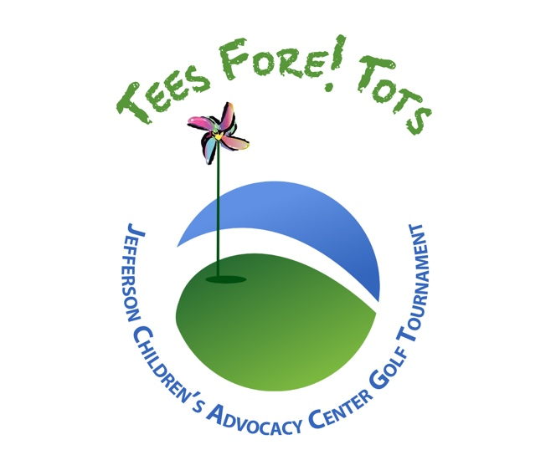
Sponsor

Packages

Monday, October 3, 2022
Chateau Golf & Country Club
WWW.JEFFERSONCAC.COM

TITLE SPONSOR - 1 Available Investment $10,000
- Company Name in Title of the Event
- Company Name and Logo in all Promotional Materials
- Company Name in all Advertising and PR efforts
- Company Name on Event Signage
- Company Information given to all Participants
- 2 Foursomes
- Display Table for Company Promotional Opportunity during Event
- Company executive to MC Awards Ceremony
- Business category exclusivity
- Agree to a 3-year commitment

PRESENTING SPONSOR - 1 Available Investment $7,500
- Company Name and Logo in all Promotional Material
- Company Name in all Advertising and PR efforts
- Event Signage, Hole Signs, Banners, Tee Boxes, Carts
- Company information given to all participants
- Company logo on the player gift for all players
- 1 Foursome
- Display Table for Company Promotional Opportunity during Event
- Company Name and Logo on Winners Trophies
- Business Category Exclusivity

TEE GIFT SPONSOR - 1 Available Investment $5,000

- Golf for Foursome Included in Tournament
- Recognition as Player Gift Sponsor on all print and media promotions
- Large Company Logo on Tournament Website
- Company Banner Displayed at Tournament
- Opportunity to provide promotional items on-course
- Public Recognition of sponsorship during luncheon & award presentation
- Featured Mention in the Newsletter

GOLF CART SPONSOR - 1 Available Investment $2,500

- Golf for Foursome Included in Tournament
- Recognition as Golf Cart Sponsor on all print and media promotions
- Large Company Logo on Tournament Website
- Company Banner Displayed at Tournament
- Opportunity to provide promotional items on player golf carts
- Public Recognition of sponsorship during luncheon & award presentation
- Featured Mention in the Newsletter

AWARDS PARTY SPONSOR - 1 Available Investment $2,500

- Golf for Foursome Included in Tournament
- Recognition as Awards Party Sponsor on all print and media promotions
- Large Company Logo on Tournament Website
- Company Banner Displayed at Awards Party
- Opportunity to provide promotional items at Awards Party
- Representative to present awards with executive director
- Featured Mention in the Newsletter

HOSPITALITY SPONSOR – 5 Available Investment $1,500
(TALK – LISTEN – HELP – COMFORT – HEAL)
- Recognition as Hole Sponsor on Tournament Webpage
- Small Company Logo on Tournament Website
- Opportunity to station personnel at hole during the tournament
- Opportunity to provide promotional items at location on course
- Company Banner at Hole

CORPORATE SPONSOR - Unlimited Investment $1,200

- Golf for four players
- Player gift for four players
- Lunch, on course hospitality and beverages throughout the day
- Invitation to Awards Reception for four players

PIN FLAG SPONSOR – 18 Available Investment $250

- Recognition as Pin Flag Sponsor on Tournament Webpage
- Small Company Logo on Tournament Website
- Opportunity to station personnel at hole during the Tournament

EVENT SPONSOR - Unlimited Investment $200

- Name recognition on event sign displayed during tournament
INDIVIDUAL PLAYER Investment $200

- One playing spot
- Lunch, on course hospitality and beverages throughout the day
- Invitation to Awards Reception

